SALES REVENUE PERFORMANCE DASHBOARD REPORTS

ABOUT THIS PROJECT:
My project is a Sales Revenue Performance Dashboard. It is designed to track sales and revenue of different outlets, analyze trends, and help managers make data-driven decisions. The dashboard shows key metrics like total sales, average sales, number of items sold, and revenue growth, and provides visual insights through charts and filters.

DATA CLEANING & TRANSFORMATION:
I did data cleaning and data transformation in Power BI using Power Query, before creating the dashboard.
after importing this retail grocery sales dataset into Power BI, I performed data cleaning and data transformation in Power Query. In this dataset, I removed duplicate records, checked and handled missing values, corrected data types, and standardized columns like item fat content. After cleaning the data, I transformed it by grouping sales based on item type, outlet type, outlet size, and outlet location tier. This process was done before creating any visuals or dashboards to make sure the analysis is accurate and meaningful.
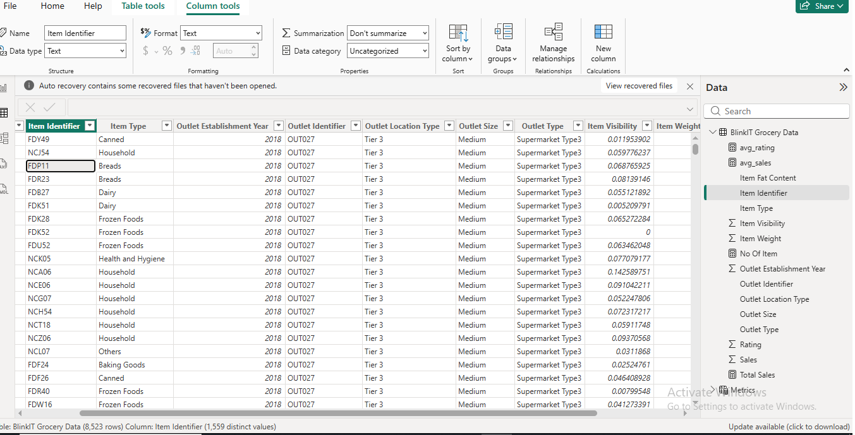
DAX FUNCTIONS:

TOTAL SALES:
Total SUM ('Blink IT Grocery Data'[Sales])
AVERAGE SALES:
avg_sales = AVERAGE ('BlinkIT Grocery Data'[Sales])
AVERAGE RATING:
avg_rating = AVERAGE ('BlinkIT Grocery Data'[Rating])
NO OF ITEMS:
No of Item = COUNTROWS ('BlinkIT Grocery Data')

About the Dashboard:
This dashboard shows retail sales performance.
It helps us understand sales, items, outlet performance, and customer performance
KPI’S:
- Total Sales: 1.20 million
- Average Sales: 141
- Number of Items: 8,523
- Average Rating: 3.92
These KPIs give a quick overview of the overall business performance.
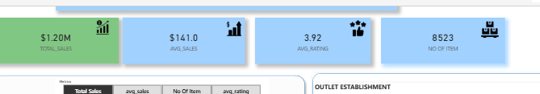

Fat Content Analysis:
This donut chart shows sales by fat content.
- Low Fat products contribute more sales than regular products.
This helps to understand customer preference.
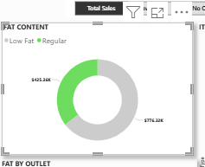

Sales by Outlet:
This bar chart shows fat content sales by outlet type.
It helps to compare how different outlets perform.
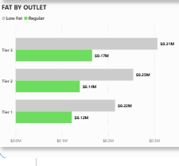
Item Type Analysis:
This chart shows sales by item type.
From this, we can identify which product categories generate more revenue.
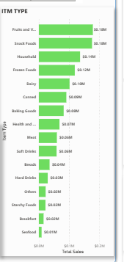

Outlet Establishment Trend:
This area chart shows sales based on outlet establishment year.
It shows that sales increased after 2015, which indicates business growth.
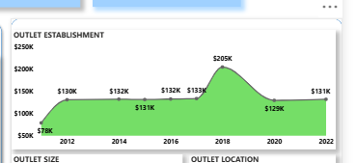

Outlet Size and Location:
- Medium-size outlets generate higher sales.
- Tier 3 locations perform better compared to other locations.
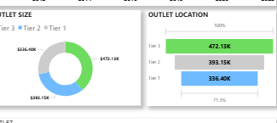

Outlet Type Summary:
This table shows:
- Total Sales
- Number of Items
- Average Sales
- Average Rating
It helps to compare the performance of each outlet type clearly.
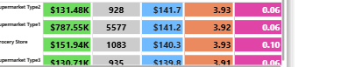
Filter panel:
Filter Panel is used to filter the dashboard data based on user selection.
It allows users to view data according to their requirement.
In this dashboard, the filter panel includes:
- Outlet Location Type (Tier 1, Tier 2, Tier 3)
- Outlet Size (Small, Medium, Large)
- Item Type
By using these filters, all KPIs and charts update dynamically.
This helps in analyzing sales performance for specific locations, outlet sizes, and product categories.
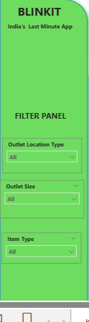
Over all dashboard:
This dashboard provides a clear view of the overall sales performance. It displays key KPIs such as Total Sales, Average Sales, Number of Items, and Average Rating.
The filter panel allows users to select Outlet Location, Outlet Size, and Item Type. Based on the selection, all charts and KPIs update automatically.
The charts help analyze sales by fat content, item type, outlet size and type, and outlet establishment year. Overall, this dashboard helps to understand business performance and supports better decision-making.
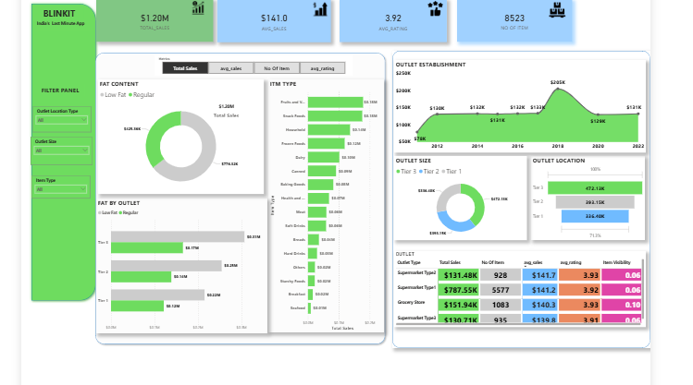

Insights & analysis:

• Supermarket Type 1 generates higher total sales compared to grocery stores.
• Tier 1 outlets show better sales performance than other tiers.
• Low Fat products contribute more to total sales than Regular products.
• Medium and Large outlet sizes perform better in terms of sales.
• Older outlets show stable and higher sales compared to newly established outlets.
• Average customer rating is almost the same across outlet types, showing consistent customer satisfaction.

Conclusion:
Overall, this Power BI dashboard successfully analyzes sales data using interactive filters and visualizations. It helps in identifying high-performing outlets, popular product categories, and key sales trends. This project demonstrates effective use of data cleaning, transformation, DAX functions, and dashboard design to support data-driven business decisions.

